Join us for our April 11 Activity Day (9:30 – 3) mystery project and potluck. Bring a lunch item to share. Warming trays, plates, and utensils provided.
Our project is an 18" octagon. You bring your fabrics and I'll supply the templates. If you have a 60 degree ruler - please bring it.
This sneak peek of the project may help inspire your fabric choices.
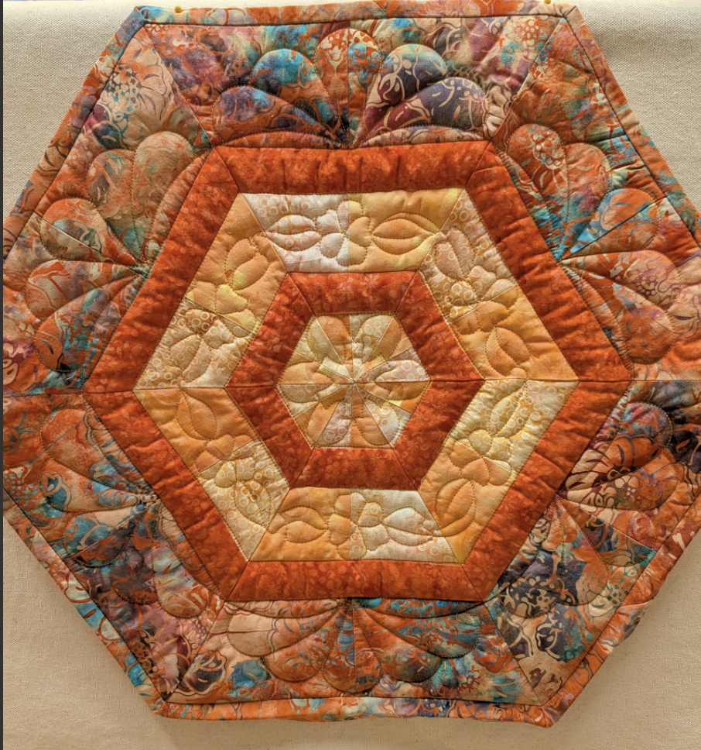
You'll need: (sewing machine and 1/4" foot, usual sewing supplies, matching thread)
2) 1/6 yard each accent fabric (2 fabrics)
1/8 yard for inner narrow border
1/8 yard for the middle narrow border
1/4 yard outer border
Cutting:
Both accent fabrics - 12 each) 2 1/2" x 6 1/2" rectangles
Inner border - 6) 1 1/2" x 12 1/2" rectangles
Middle border - 6) 1 1/2" x 12 1/2" rectangles
Outer border - 12) 3 1/2" x 12 1/2" rectangles
Binding - 2) 2 3/8" x 42" strips

