On December 7,2023, NIQ President Linda Cathey, and the **Quilt Show Publicity Committee** stopped by the Kootenai Health Foundation’s Davidson Family Hospitality Center to drop off a donation of 28 quilts and 20 handcrafted Christmas Stockings. The donation was organized by NIQ member and Kootenai Health employee Della Jenkins. While there, we were invited to visit their Santa’s workshop, which supports residents of the Hospitality Center at Christmas. Look for a mention of our contribution and our upcoming NIQ 2024 Quilt Show on the Kootenai Foundations newsletter, and facebook and Instagram pages.

In attendance, in addition to the NIQ President Linda Cathey, were NIQ Members Mary Brewer, Della Jenkins, Lisa Reeder, Suzanne Zabriskie, Alice Sherman, and Jan Zodrow, as well as Cara Nielson, President of the Kootenai Health Foundation.

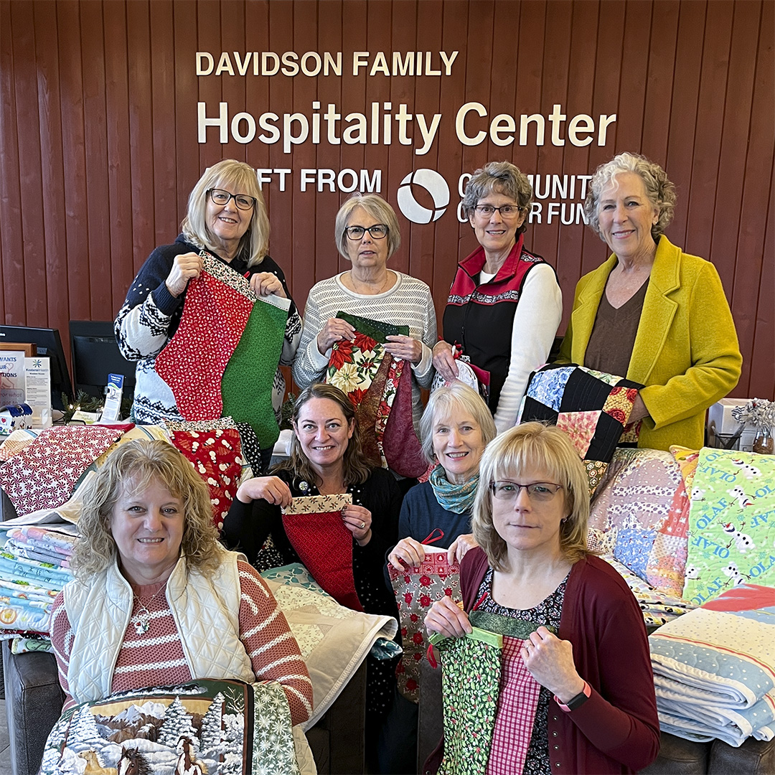

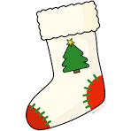

The inaugural year of Project Christmas stocking was a huge success with a final tally of 350 stockings. The stockings were shared among the following charities.

* Family Promise received 70
* Childrens Village received 10
* Kootenai Health Foundation received 20, along with 28 Quilts
* Post Falls Food Bank received 120, and
* Mission Community Outreach received the balance of 130

Now that 2023 is done, let’s Make 2024 another big year with a goal of 400 stockings. **There will be a cutting party in February. We will cut out stockings, and then convert Christmas scraps into pieces that can be used for community service quilts. Watch for details on our Members’ only Facebook page.**

**Don’t forget Community Service sew day on the 3rd Friday of each month and the Community Service quilt tying on the 2nd Tuesday of each month. Check the NIQ Calendar in this issue for exact dates.**

**Come on down and join us. Its sure to put a smile on your face.**